UNITED STATES

SECURITIES AND EXCHANGE COMMISSION
Washington, D.C. 20549

FORM 8-K

Current Report

Pursuant to Section 13 or 15(d)
of the Securities Exchange Act of 1934

Date of report (Date of earliest event reported): December 14, 2015 (December 13, 2015)

NEWELL RUBBERMAID INC.

(Exact name of registrant as specified in its charter)

Delaware

1-9608

36-3514169

(State or Other Jurisdiction
of Incorporation)

(Commission
File Number)

(IRS Employer
Identification Number)

3 Glenlake Parkway

Atlanta, Georgia 30328

(Address of principal executive offices including zip code)

(770) 418-7000

(Registrant’s telephone number, including area code)

Check the appropriate box below if the Form 8-K filing is intended to simultaneously satisfy the filing obligation of the registrant under any of the following provisions (see

General Instruction A.2. below):

- Written communications pursuant to Rule 425 under the Securities Act (17 CFR 230.425)

- Soliciting material pursuant to Rule 14a-12 under the Exchange Act (17 CFR 240.14a-12)

- Pre-commencement communications pursuant to Rule 14d-2(b) under the Exchange Act (17 CFR 240.14d-2(b))

- Pre-commencement communications pursuant to Rule 13e-4(c) under the Exchange Act (17 CFR 240.13e-4(c))

Item 7.01 Regulation FD Disclosure.

A copy of the joint press release referenced below is furnished as Exhibit 99.1 to this Current Report on Form 8-K and is incorporated by reference herein. The investor presentation to be used in connection with the teleconference referenced below, the internal email announcement to Newell Rubbermaid employees, the internal Connect article, and the announcement to Newell Rubbermaid customers are furnished as Exhibits 99.2, 99.3, 99.4 and 99.5, respectively, to this Current Report on Form 8-K and are incorporated by reference herein.

Item 8.01 Other Events.

On December 14, 2015, Newell Rubbermaid Inc., a Delaware corporation (“Newell”), and Jarden Corporation, a Delaware corporation (“Jarden”), issued a joint press release announcing that they had entered into an Agreement and Plan of Merger (the “Merger Agreement”), dated as of December 13, 2015, by and among Newell, Jarden, NCPF Acquisition Corp. I, a Delaware corporation and a wholly-owned subsidiary of Newell (“Newell Merger Sub”), and NCPF Acquisition Corp. II, a Delaware corporation and a wholly-owned subsidiary of Newell (“Successor Merger Sub”), pursuant to which Newell will combine with Jarden in a series of merger transactions (the “Combination”).

Newell Merger Sub will merge with and into Jarden (the “Jarden Merger”), with Jarden continuing as the surviving corporation and as a wholly-owned subsidiary of Newell. Immediately following the effectiveness of the Jarden Merger, Jarden will merge with and into Successor Merger Sub, with Successor Merger Sub continuing as the surviving corporation (the “Successor Merger Sub Merger” and, together with the Jarden Merger, the “Combined Mergers”). As a result of the Combined Mergers, the Successor Merger Sub with the legacy business of Jarden will become a direct wholly-owned subsidiary of Newell. Following the consummation of the Combination, Newell will change its name to Newell Brands Inc.

Newell and Jarden will be providing supplemental information regarding the Combination through a teleconference with analysts and investors.

Caution Concerning Forward Looking Statements

Statements that are not historical in nature constitute forward-looking statements. These forward-looking statements relate to information or assumptions about the timing of completion of the proposed combination, the expected benefits of the proposed combination, management’s plans, projections and objectives for future operations, scale and performance, integration plans and expected synergies therefrom, and anticipated future financial and operating performance results, including operating margin or gross margin capital and other expenditures, cash flow, dividends, restructuring and other project costs, costs and cost savings, and debt ratings. These statements are accompanied by words such as “anticipate,” “expect,” “project,” “will,” “believe,” “estimate” and similar expressions. Such expectations are based upon certain preliminary information, internal estimates, and management assumptions, expectations, and plans, and are subject to a number of risks and uncertainties inherent in projecting future conditions, events, and results. Actual results could differ materially from those expressed or implied in the forward-looking statements if one or more of the underlying assumptions or expectations prove to be inaccurate or are unrealized. Important factors that could cause actual results to differ materially from those suggested by the forward-looking statements include, but are not limited to, the occurrence of any event, change or other circumstances that could give rise to the termination of the merger agreement; the risk that the necessary shareholder approvals may not be obtained; the risk that the necessary regulatory approvals may not be obtained or may be obtained subject to conditions that are not anticipated; the risk that the proposed combination will not be consummated in a timely manner; risks that any of the closing conditions to the proposed combination may not be satisfied or may not be satisfied in a timely manner; risks related to disruption of management time from ongoing business operations due to the proposed combination; the risk that we are unable to retain our investment grade rating; failure to realize the benefits expected from the proposed combination; failure to promptly and effectively integrate the combination; and the effect of the announcement of the proposed combination on the ability of Newell Rubbermaid to retain customers and retain and hire key personnel, maintain relationships with suppliers, on its operating results and businesses generally and those factors listed in Newell Rubbermaid’s most recently filed Quarterly Report on Form 10-Q and exhibit 99.1 thereto, in each case, filed with the Securities and Exchange Commission (“SEC”). Changes in such assumptions or factors could produce significantly different results. The information contained in this Current Report on Form 8-K is as of the date indicated. Newell Rubbermaid does not assume any obligation to update any forward-looking statements contained in this Current Report on Form 8-K as a result of new information or future events or developments.

Additional Information and Where to Find It

In connection with the proposed combination, Newell Rubbermaid and Jarden will file a registration statement on Form S-4 that will include the Joint Proxy Statement of Newell Rubbermaid and Jarden that also constitutes a prospectus of Newell Rubbermaid. Newell Rubbermaid and Jarden plan to mail to their respective shareholders the Joint Proxy Statement/Prospectus in connection with the combination. WE URGE INVESTORS AND SHAREHOLDERS TO READ THE JOINT PROXY STATEMENT/PROSPECTUS AND ANY OTHER RELEVANT DOCUMENTS WHEN THEY BECOME AVAILABLE, BECAUSE THEY WILL CONTAIN IMPORTANT INFORMATION ABOUT NEWELL RUBBERMAID, JARDEN, AND THE PROPOSED COMBINATION. Investors and shareholders will be able to obtain copies of the Joint Proxy Statement/Prospectus and other documents filed with the SEC by Newell Rubbermaid and Jarden free of charge at the SEC’s website, www.sec.gov. In addition, investors and shareholders will be able to obtain free copies of the Joint Proxy Statement/Prospectus and other documents filed with the SEC by Newell Rubbermaid by accessing Newell Rubbermaid’s website at www.newellrubbermaid.com by clicking on the “Investor Relations” link and then clicking on the “SEC Filings” link or by contacting Newell Rubbermaid Investor Relations at investor.relations@newellrubbermaid.com or by calling 1-800-424-1941, and will be able to obtain free copies of the Joint Proxy Statement/Prospectus and other documents filed with the SEC by Jarden by accessing Jarden’s website at www.Jarden.com by clicking on the “For Investors” link and then clicking on the “SEC Filings” link or by contacting Jarden Investor Relations at rwilson@jarden.com or by calling 203-845-5300. Shareholders may also read and copy any reports, statements and other information filed by Newell Rubbermaid or Jarden with the SEC, at the SEC public reference room at 100 F Street, N.E., Washington D.C. 20549. Please call the SEC at 1-800-SEC-0330 or visit the SEC’s website for further information on its public reference room.

Participants in the Merger Solicitation

Newell Rubbermaid, Jarden and certain of their respective directors, executive officers and other persons may be considered participants in the solicitation of proxies from the respective shareholders of Newell Rubbermaid and Jarden in respect of the proposed combination contemplated by the Joint Proxy Statement/Prospectus. Information regarding Newell Rubbermaid’s directors and executive officers is available in Newell Rubbermaid’s Form 10-K filed with the SEC on March 2, 2015, its proxy statement filed with the SEC on April 1, 2015 in connection with its 2015 annual meeting of stockholders and its Forms 8-K filed with the SEC on February 12, 2015, May 19, 2015, October 9, 2015 and November 16, 2015. Information regarding Jarden’s directors and executive officers is available in Jarden’s Form 10-K filed with the SEC on March 2, 2015, its proxy statement filed with the SEC on April 20, 2015 in connection with its 2015 annual meeting of stockholders and its Forms 8-K filed with the SEC on January 5, 2015 and June 9, 2015. Other information regarding persons who may be considered participants in the proxy solicitation and a description of their direct and indirect interests, by security holdings or otherwise, will be contained in the Joint Proxy Statement/Prospectus and other relevant materials to be filed with the SEC when they become available.

Non-Solicitation

This communication is not intended to and does not constitute an offer to sell or the solicitation of an offer to subscribe for or buy or an invitation to purchase or subscribe for any securities or the solicitation of any vote or approval in any jurisdiction pursuant to the combination or otherwise, nor shall there be any sale, issuance or transfer of securities in any jurisdiction in contravention of applicable law. No offer of securities shall be made except by means of a prospectus meeting the requirements of Section 10 of the Securities Act of 1933, as amended.

Item 9.01 Financial Statements and Exhibits.

- Exhibits

Exhibit | Exhibit Description
No.
99.1 | Joint Press Release, dated December 14, 2015, issued by Newell Rubbermaid Inc. and Jarden Corporation.
99.2 | Investor Presentation, dated December 14, 2015
99.3 | Email Announcement to Newell Rubbermaid Employees on December 14, 2015
99.4 | Newell Rubbermaid Connect Article Posted on December 14, 2015
99.5 | Email Announcement to Newell Rubbermaid Customers on December 14, 2015

SIGNATURES

Pursuant to the requirements of the Securities Exchange Act of 1934, the Registrant has duly caused this report to be signed on its behalf by the undersigned hereunto duly authorized.

Date: December 14, 2015

NEWELL RUBBERMAID INC.

By: /s/ Bradford R. Turner

Bradford R. Turner

Senior Vice President, General Counsel and

Corporate Secretary

 |  |  | EXHIBIT INDEX
Exhibit | Exhibit Description
No.
99.1 | Joint Press Release, dated December 14, 2015, issued by Newell Rubbermaid Inc. and Jarden Corporation.
99.2 | Investor Presentation, dated December 14, 2015
99.3 | Email Announcement to Newell Rubbermaid Employees on December 14, 2015
99.4 | Newell Rubbermaid Connect Article Posted on December 14, 2015
99.5 | Email Announcement to Newell Rubbermaid Customers on December 14, 2015
Exhibit 99.1
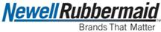
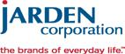

NEWS RELEASE

Newell Rubbermaid and Jarden Corporation Announce

Consumer Goods Combination with $16 Billion Revenue

    - Strong portfolio of leading brands to be called Newell Brands

  - Transaction expected to be immediately accretive to normalized EPS

- Substantial revenue synergies and $500 million cost synergies over four years

Executive Summary

- Jarden shareholders will receive, for each Jarden share, $21 in cash and 0.862 of a share in Newell Rubbermaid stock at closing; Newell Rubbermaid shareholders will own approximately 55 percent of the company after the transaction is complete

- Combination creates $16 billion consumer goods company with portfolio of power brands in large, growing and unconsolidated global markets

- Transaction expected to substantially scale presence in key retailers, channels, and geographies resulting in increased speed and impact of extended distribution, cross-sell, and market deployment

- Complementary portfolios expected to accelerate existing business plans and growth in Food & Beverage, Baby Products, Commercial Products, Kitchenware & Appliances

- Newell Brands expects to be a leader in innovation, brand building and best-in-class execution with an increased exposure to fast growing eCommerce channels and scaled presence in priority international markets

- $500 million in incremental cost synergies expected over the next four years; combination expected to be immediately accretive with strong double digit normalized earnings per share accretion post synergy realization

- Newell Brands expects to maintain investment grade rating due to the combined business’ strong cash generative profile and commitment to a target leverage ratio of 3.0 to 3.5 times following a temporary increase in leverage metrics

- Annualized dividend per share will be maintained at or above the current Newell Rubbermaid annualized level of $0.76 per share

- Annual adjusted EBITDA of over $3 billion post synergies creates long-term opportunity to strengthen the company further through active portfolio management

- Michael B. Polk, currently Chief Executive Officer of Newell Rubbermaid, to become Chief Executive Officer of Newell Brands. Mark S. Tarchetti, currently Chief Development Officer of Newell Rubbermaid, to become President of Newell Brands upon completion of the transaction

- Three Jarden Corporation Directors to join the Newell Brands Board of Directors, including Martin E. Franklin, Founder and Executive Chairman of Jarden, and Ian G. H. Ashken, Co-Founder, Vice Chairman and President of Jarden

- Michael T. Cowhig, currently non-executive Chairman of Newell Rubbermaid, to remain non-executive Chairman of thirteen member Newell Brands Board of Directors

- Investment community conference call to be held today at 8:00 a.m. ET

ATLANTA and MIAMI, December 14, 2015 – Newell Rubbermaid (NYSE: NWL) and Jarden Corporation (NYSE: JAH) today announced that they have entered into a definitive agreement to combine the two companies. The transaction creates a $16 billion consumer goods company to be named Newell Brands, with a portfolio of leading brands in large unconsolidated categories, including Paper Mate®, Sharpie®, EXPO®, Parker®, Elmer’s®, Calphalon®, Rubbermaid®, Graco®, Baby Jogger®, Aprica®, Goody®, Irwin®, Lenox®, Rubbermaid Commercial Products®, Coleman®, First Alert®, FoodSaver®, Jostens®, K2®, NUK®, Oster®, Rawlings®, Sunbeam® and Yankee Candle®. The scaled enterprise is expected to accelerate profitable growth with leading brands that compete in a global market that exceeds $100 billion, with business and capability development supported by the efficiencies of this transformational combination.

“The combination of these two great companies creates a $16 billion consumer goods company with incredible potential to grow and create value,” said Michael B. Polk, Newell Rubbermaid President and Chief Executive Officer. “The scale of our combined businesses in key categories, channels and geographies creates a much broader canvas on which to leverage our advantaged set of brand development and commercial capabilities for accelerated growth and margin expansion. I have long respected the value creation track record and entrepreneurial vision of Jarden’s founder, Martin E. Franklin, co-founder Ian G.H. Ashken, and their team led by Chief Executive Officer James E. Lillie. I want to congratulate Jim on his strong leadership of Jarden over the last twelve years and his work positioning the business for the opportunity ahead, and I look forward to working with Martin and Ian as we drive the new Newell Brands towards its aspiration of becoming one of the preeminent consumer goods companies in the world.”

Martin E. Franklin, Executive Chairman and Founder of Jarden, said “I am delighted that we are to play a part in bringing together these two winning companies. The combination offers significant value for our shareholders and the opportunity to participate in the combined company’s long-term value creation potential as shareholders in Newell Brands. I’m extremely proud of Jarden’s success over the past 14 years, which has been driven by an extraordinary culture designed to perform at a high level. We have spent significant time with Newell Rubbermaid’s senior management team and are convinced they have a similar ambition and drive. I’m excited by the opportunities for this new combined organization and I look forward to being part of this dynamic new chapter.”

James E. Lillie, Chief Executive Officer of Jarden, added, “This combination is focused on driving shareholder value and accelerating the growth and profitability of both businesses. Together, the business can move faster, globally leveraging the expertise and ability of the dedicated and talented employee base. The combined scale of both businesses will create opportunities for shareholders, customers and employees as the two businesses are very complementary in vision and in their ability to execute. I unequivocally support Mike and the combined teams in executing against the opportunity before us.”

Transaction Summary

Under the terms of the agreement, Jarden shareholders will receive, for each Jarden share, $21 in cash and 0.862 shares of Newell Rubbermaid stock at closing. Based on Newell Rubbermaid’s closing share price as of December 11, 2015, the implied total consideration would be $60 per share, which represents a 24 percent premium to Jarden’s 30-day volume weighted average share price as of December 11, 2015.

The transaction will be funded by cash on hand, debt and equity issued to Jarden shareholders; convertible bondholders will be entitled to convert in exchange for the merger consideration in conjunction with the transaction. Newell Rubbermaid has obtained a committed bridge facility, which it expects to replace with permanent financing prior to closing. Newell Brands intends to maintain its investment grade credit rating by using strong cash flow from the combined company to prioritize debt reduction in the short term towards a target leverage ratio of 3.0 to 3.5 times. Newell Brands expects to achieve the target ratio within two to three years, while simultaneously maintaining or increasing its dividend per share.

Newell Rubbermaid anticipates incremental annualized cost synergies of approximately $500 million over four years, driven by efficiencies of scale and new efficiencies in procurement, cost to serve and infrastructure that the combination unlocks. The company’s intent is to design a benchmarked, efficient set of structures that support long term business development. The transaction is projected to be immediately accretive with strong double-digit normalized earnings per share accretion post synergy realization.

The acquisition is subject to approval by shareholders of both Newell Rubbermaid and Jarden Corporation, receipt of regulatory approvals and other customary closing conditions. The transaction is expected to close in the second quarter of 2016.

Management and Governance

Upon the closing of the transaction, Newell Brands will be led by Michael B. Polk as Chief Executive Officer.

The Newell Brands Board of Directors will be expanded to include three representatives of the Jarden Board, including Martin E. Franklin, Founder and Executive Chairman of Jarden and Ian G. H. Ashken, Co-Founder, Vice Chairman and President of Jarden. The new thirteen member Newell Brands Board will be chaired by current Newell Rubbermaid non-executive Chairman Michael Cowhig.

Mark Tarchetti, currently Chief Development Officer, Newell Rubbermaid, will become the President of Newell Brands upon completion of the transaction, with an initial focus leading the integration of the companies, including synergy delivery, portfolio strategy and long-term business development plans such as accelerated market deployment of the brands at home and internationally. He will also be responsible for the creation of a number of enterprise-wide capabilities, including Design, Innovation, Insights, eCommerce, and Direct-to-Consumer commerce.

Bill Burke, currently Chief Operating Officer, Newell Rubbermaid, will lead the legacy Jarden business upon completion of the transaction, working closely with Richard Sansone, Jarden’s Executive Vice President of Operations and the senior leadership teams across the Jarden businesses to deliver the current business plans while working with Mark Tarchetti to insure the seamless transition of Jarden into Newell Brands.

“Given the magnitude of the opportunity ahead, I’m delighted that Bill and Mark will continue their partnership working with Rich and the great talent that Jarden brings to the combination. This is an important time, and the process of learning more about the brands, the people and the opportunities represented by the combined business is critical to realization of the full potential of the transformation,” said Polk.

As previously announced, Joe Arcuri will assume the role of Chief Commercial Officer, Newell Rubbermaid and Richard Davies will become Chief Development Officer, Newell Rubbermaid, both effective January 1, 2016. These leaders will ensure the development and full delivery of the existing Newell Rubbermaid business plan.

Additional executive roles will be announced at the completion of the proposed transaction.

Advisors

Goldman, Sachs & Co. served as lead financial advisor to Newell Rubbermaid and is providing committed financing for the transaction; Centerview Partners LLC acted as financial advisor to the Newell Rubbermaid Board of Directors. Jones Day and Simpson Thacher & Bartlett acted as legal counsel to Newell Rubbermaid.

Barclays acted as lead financial advisor with UBS Investment Bank also serving as financial advisor for Jarden; Greenberg Traurig LLP and Kane Kessler P.C. acted as legal counsel.

Investor Call Details

Newell Rubbermaid and Jarden will host a conference call with investors to discuss the announcement today, December 14, 2015, at 8:00 a.m. ET. A link to the listen-only webcast and a supporting slide presentation is provided under Events & Presentations in the Investor Relations section of Newell Rubbermaid’s Web site at www.newellrubbermaid.com and is similarly posted on Jarden’s Web site at www.jarden.com. A webcast replay will be made available in the Investor Relations section on both companies’ Web sites.

About Newell Rubbermaid

Newell Rubbermaid Inc., an S&P 500 company, is a global marketer of consumer and commercial products with 2014 sales of $5.7 billion and a strong portfolio of leading brands, including Sharpie®, Paper Mate®, Elmer’s®, Irwin®, Lenox®, Rubbermaid Commercial Products®, Contigo®, Rubbermaid®, Calphalon®, Goody®, Graco®, Aprica®, Baby Jogger®, Dymo®, Parker® and Waterman®. As part of the company’s Growth Game Plan, Newell Rubbermaid is making sharper portfolio choices and investing in new marketing and innovation to accelerate performance.

This press release and additional information about Newell Rubbermaid are available on the company’s Web site, www.newellrubbermaid.com.

About Jarden Corporation

Jarden Corporation is a diversified, global consumer products company with a portfolio of over 120 trusted, authentic brands. Jarden’s record of strong financial performance and organic growth is supported by a focused operating culture coupled with value enhancing acquisitions and shareholder focused capital allocation. Jarden operates in three primary business segments through a number of well recognized brands, including: Branded Consumables: Ball®, Bee®, Bernardin®, Bicycle®, Billy Boy®, Crawford®, Diamond®, Envirocooler®, Fiona®, First Alert®, First Essentials®, Hoyle®, Kerr®, Lehigh®, Lifoam®, Lillo®, Loew-Cornell®, Mapa®, Millefiori®, NUK®, Pine Mountain®, Quickie®, Spontex®, Tigex®, Waddington, Yankee Candle® and YOU®; Outdoor Solutions: Abu Garcia®, AeroBed®, Berkley®, Campingaz® and Coleman®, Dalbello®, ExOfficio®, Fenwick®, Greys®, Gulp!®, Hardy®, Invicta®, Jostens®, K2®, Marker®, Marmot®, Mitchell®, Neff®, PENN®, Rawlings®, Shakespeare®, Squadra®, Stearns®, Stren®, Trilene®, Volkl® and Zoot®; and Consumer Solutions: Bionaire®, Breville®, Cadence®, Crock-Pot®, FoodSaver®, Health o meter®, Holmes®, Mr. Coffee®, Oster®, Patton®, Rainbow®, Rival®, Seal-a-Meal®, Sunbeam®, VillaWare® and White Mountain®. Headquartered in Florida, Jarden ranks #348 on the Fortune 500 and has over 35,000 employees worldwide. For further information about Jarden, please visit www.jarden.com.

Contacts:

Newell Rubbermaid

Nancy O’Donnell

Vice President, Investor Relations

(770) 418-7723

Racquel White

Vice President, Global Communications & Culture

(770) 418-7643

Jarden Corporation

Rachel Wilson

Vice President, Investor and Financial Relations

(203) 845-5300

Allison Malkin, ICR, Inc.

(203) 682-8225

Liz Cohen

Weber Shandwick

(212) 445-8044

Caution Concerning Forward-Looking Statements

Statements in this news release that are not historical in nature constitute forward looking statements. These forward-looking statements relate to information or assumptions about the timing of completion of the proposed acquisition, the expected benefits of the proposed acquisition, management’s plans, projections and objectives for future operations, scale and performance, integration plans and expected synergies therefrom, and anticipated future financial and operating performance results, including operating margin or gross margin capital and other expenditures, cash flow, dividends, restructuring and other project costs, costs and cost savings, and debt ratings. These statements are accompanied by words such as “anticipate,” “expect,” “project,” “will,” “believe,” “estimate” and similar expressions. Such expectations are based upon certain preliminary information, internal estimates, and management assumptions, expectations, and plans, and are subject to a number of risks and uncertainties inherent in projecting future conditions, events, and results. Actual results could differ materially from those expressed or implied in the forward-looking statements if one or more of the underlying assumptions or expectations prove to be inaccurate or are unrealized. Important factors that could cause actual results to differ materially from those suggested by the forward-looking statements include, but are not limited to, the occurrence of any event, change or other circumstances that could give rise to the termination of the merger agreement; the risk that the necessary shareholder approvals may not be obtained; the risk that the necessary regulatory approvals may not be obtained or may be obtained subject to conditions that are not anticipated; the risk that the proposed acquisition will not be consummated in a timely manner; risks that any of the closing conditions to the proposed acquisition may not be satisfied or may not be satisfied in a timely manner; risks related to disruption of management time from ongoing business operations due to the proposed acquisition; the risk that Newell Rubbermaid is unable to retain its investment grade rating; failure to realize the benefits expected from the proposed acquisition; failure to promptly and effectively integrate the acquisition; and the effect of the announcement of the proposed acquisition on the ability of Newell Rubbermaid and Jarden to retain customers and retain and hire key personnel, maintain relationships with suppliers, on their operating results and businesses generally and those factors listed in Newell Rubbermaid’s most recently filed Quarterly Report on Form 10-Q and exhibit 99.1 thereto and Jarden’s most recent Annual Report on Form 10-K for the year ended December 31, 2014, in each case, filed with the Securities and Exchange Commission (“SEC”). Changes in such assumptions or factors could produce significantly different results. The information contained in this news release is as of the date indicated. Neither Newell Rubbermaid nor Jarden assumes any obligation to update any forward-looking statements contained in this news release as a result of new information or future events or developments.

Additional Information and Where to Find it

In connection with the proposed acquisition, Newell Rubbermaid and Jarden will file a registration statement on Form S-4 that will include the Joint Proxy Statement of Newell Rubbermaid and Jarden that also constitutes a prospectus of Newell Rubbermaid. Newell Rubbermaid and Jarden plan to mail to their respective shareholders the Joint Proxy Statement/Prospectus in connection with the acquisition. WE URGE

INVESTORS AND SHAREHOLDERS TO READ THE JOINT PROXY STATEMENT/PROSPECTUS AND ANY OTHER RELEVANT DOCUMENTS WHEN THEY BECOME AVAILABLE, BECAUSE THEY WILL CONTAIN IMPORTANT INFORMATION ABOUT NEWELL RUBBERMAID, JARDEN, AND THE PROPOSED ACQUISITION. Investors and shareholders will be able to obtain copies of the Joint Proxy Statement/Prospectus and other documents filed with the SEC by Newell Rubbermaid and Jarden free of charge at the SEC’s website, www.sec.gov. In addition, investors and shareholders will be able to obtain free copies of the Joint Proxy Statement/Prospectus and other documents filed with the SEC by Newell Rubbermaid by accessing Newell Rubbermaid’s website at www.newellrubbermaid.com by clicking on the “Investor Relations” link and then clicking on the “SEC Filings” link or by contacting Newell Rubbermaid Investor Relations at investor.relations@newellrubbermaid.com or by calling 1-800-424-1941, and will be able to obtain free copies of the Joint Proxy Statement/Prospectus and other documents filed with the SEC by Jarden by accessing Jarden’s website at www.jarden.com by clicking on the “For Investors” link and then clicking on the “SEC Filings” link or by contacting Jarden Investor Relations at rwilson@jarden.com or by calling 203-845-5300. Shareholders may also read and copy any reports, statements and other information filed by Newell Rubbermaid or Jarden with the SEC, at the SEC public reference room at 100 F Street, N.E., Washington D.C. 20549. Please call the SEC at 1-800-SEC-0330 or visit the SEC’s website for further information on its public reference room.

Participants in the Merger Solicitation

Newell Rubbermaid, Jarden and certain of their respective directors, executive officers and other persons may be considered participants in the solicitation of proxies from the respective shareholders of Newell Rubbermaid and Jarden in respect of the proposed acquisition contemplated by the Joint Proxy Statement/Prospectus. Information regarding Newell Rubbermaid’s directors and executive officers is available in Newell Rubbermaid’s Form 10-K filed with the SEC on March 2, 2015, its proxy statement filed with the SEC on April 1, 2015 in connection with its 2015 annual meeting of stockholders and its Forms 8-K filed with the SEC on February 12, 2015, May 19, 2015, October 9, 2015 and November 16, 2015. Information regarding Jarden’s directors and executive officers is available in Jarden’s Form 10-K filed with the SEC on March 2, 2015, its proxy statement filed with the SEC on April 20, 2015 in connection with its 2015 annual meeting of stockholders and its Forms 8-K filed with the SEC on January 5, 2015 and June 9, 2015. Other information regarding persons who may be considered participants in the proxy solicitation and a description of their direct and indirect interests, by security holdings or otherwise, will be contained in the Joint Proxy Statement/Prospectus and other relevant materials to be filed with the SEC when they become available.

Non-Solicitation

This communication is not intended to and does not constitute an offer to sell or the solicitation of an offer to subscribe for or buy or an invitation to purchase or subscribe for any securities or the solicitation of any vote or approval in any jurisdiction pursuant to the acquisition or otherwise, nor shall there be any sale, issuance or transfer of securities in any jurisdiction in contravention of applicable law. No offer of securities shall be made except by means of a prospectus meeting the requirements of Section 10 of the Securities Act of 1933, as amended.

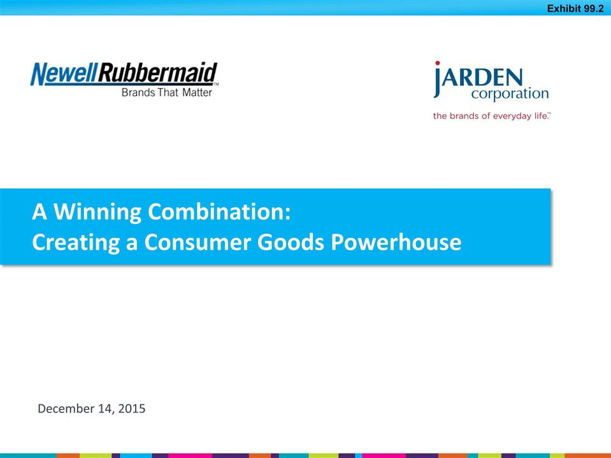

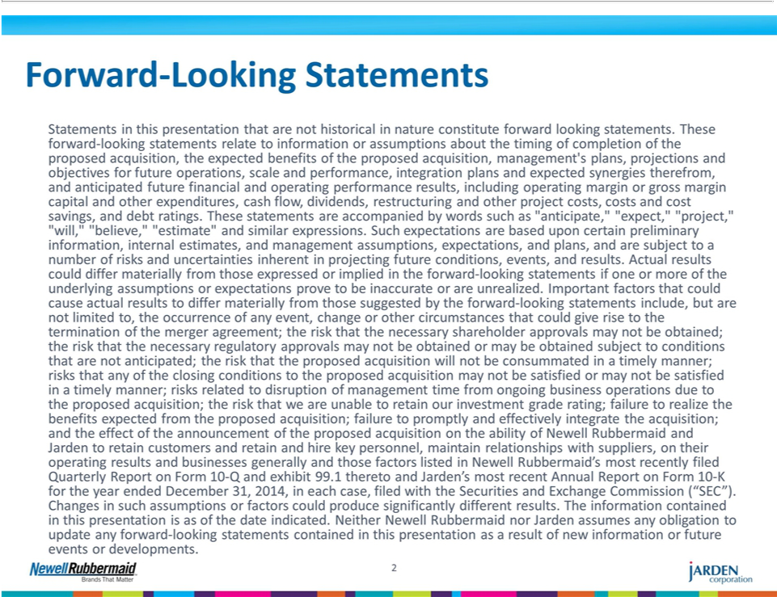

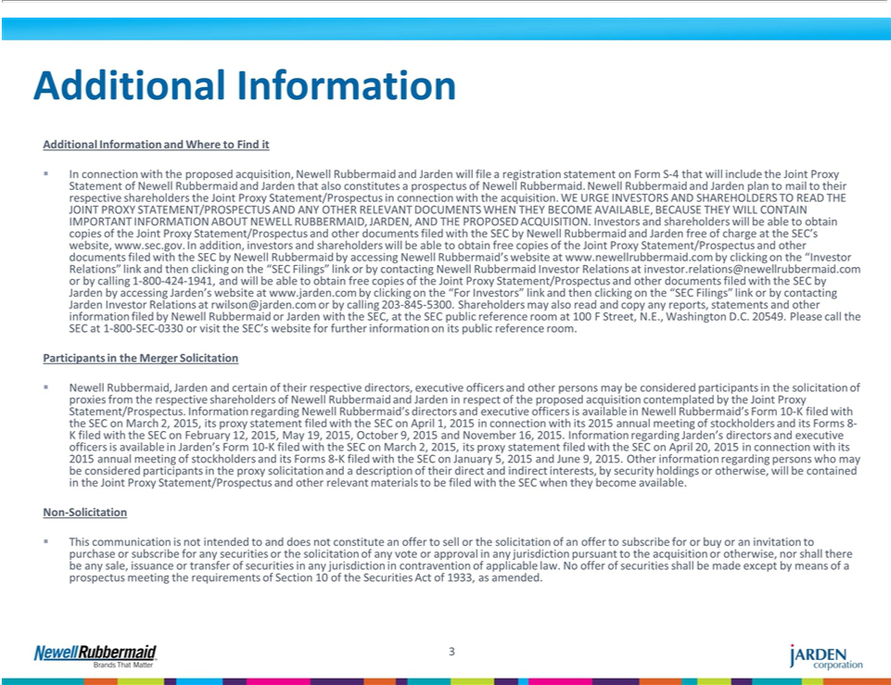

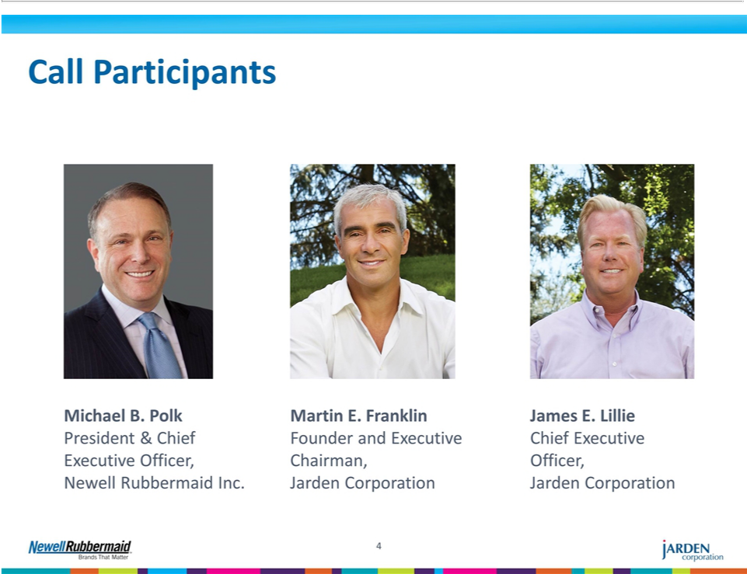

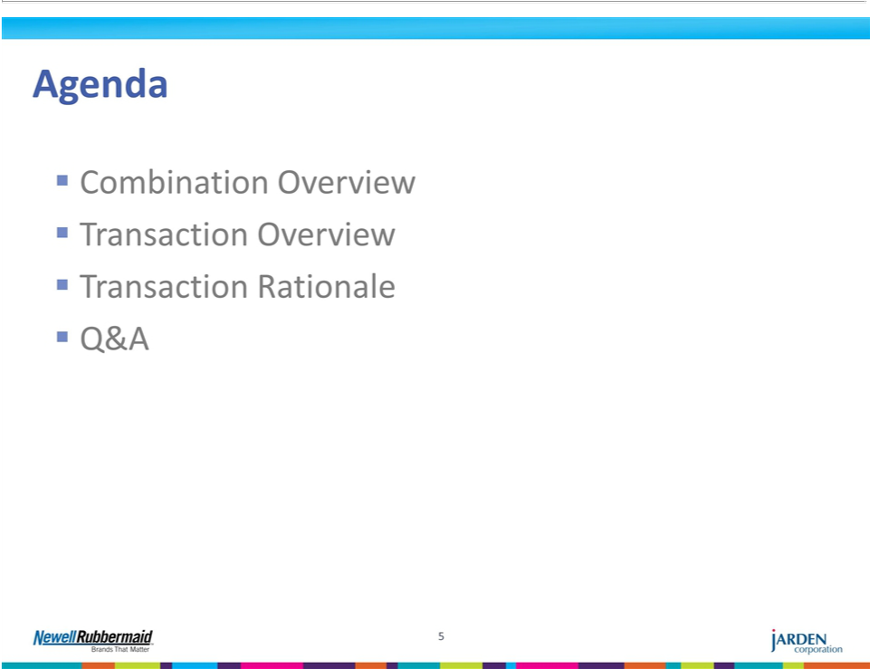

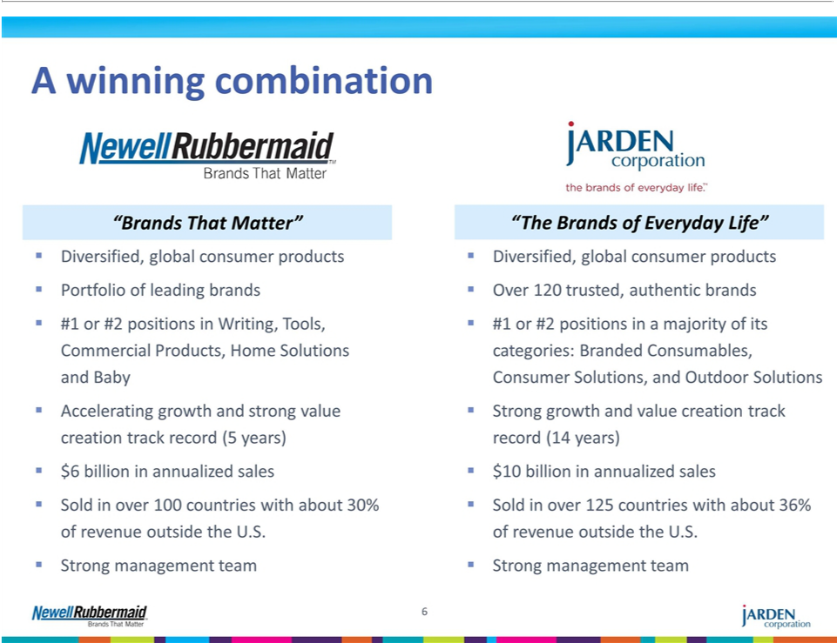

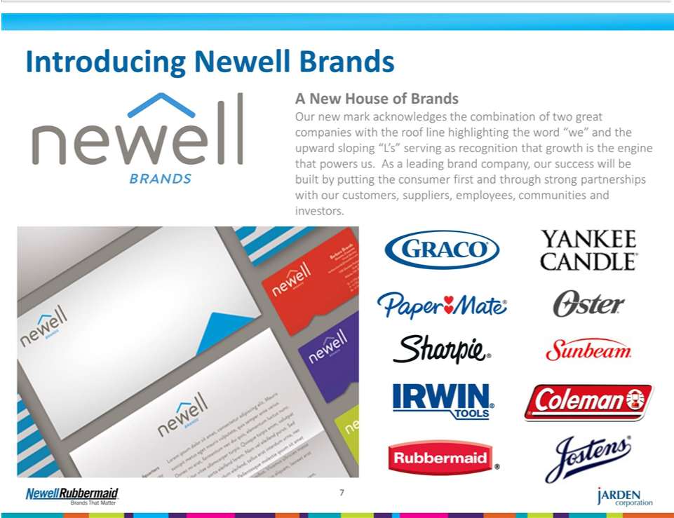

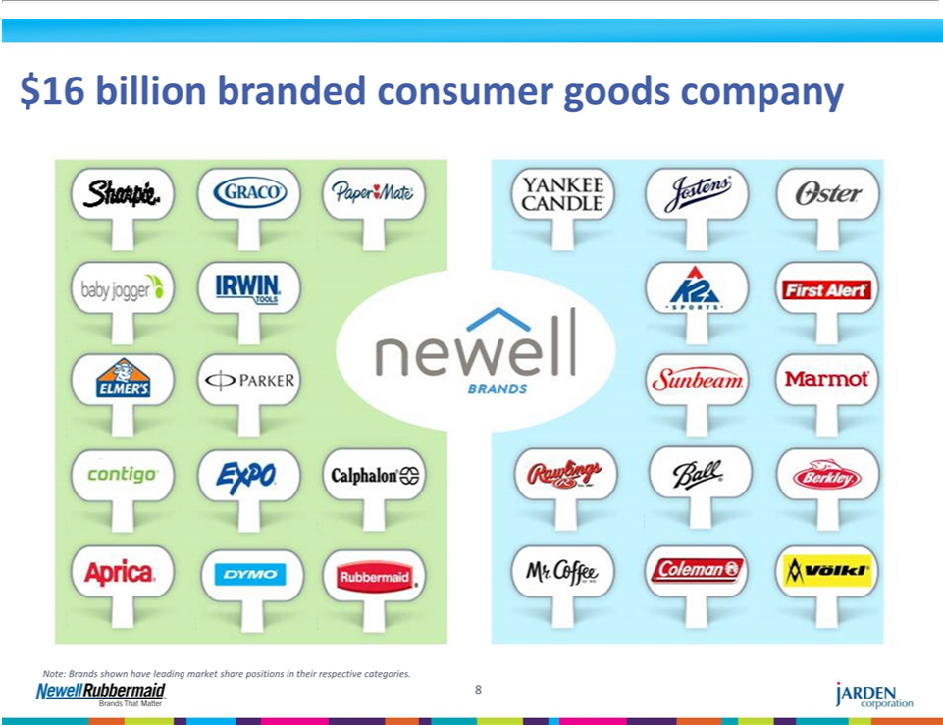

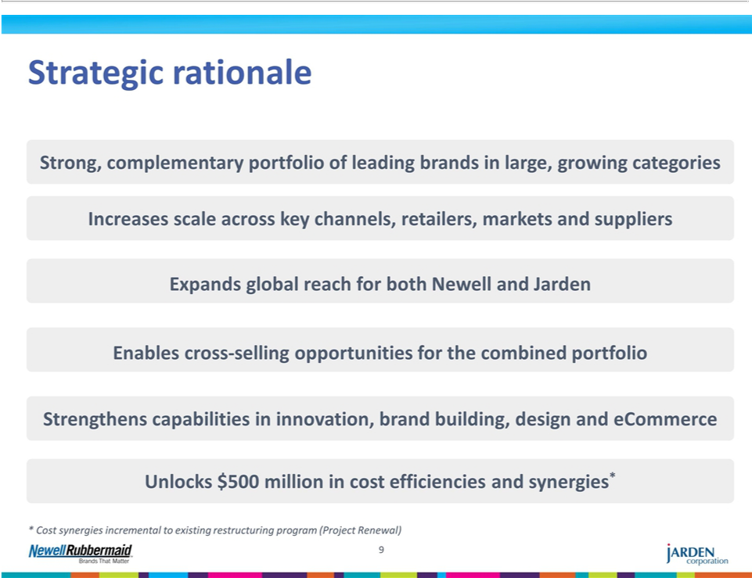

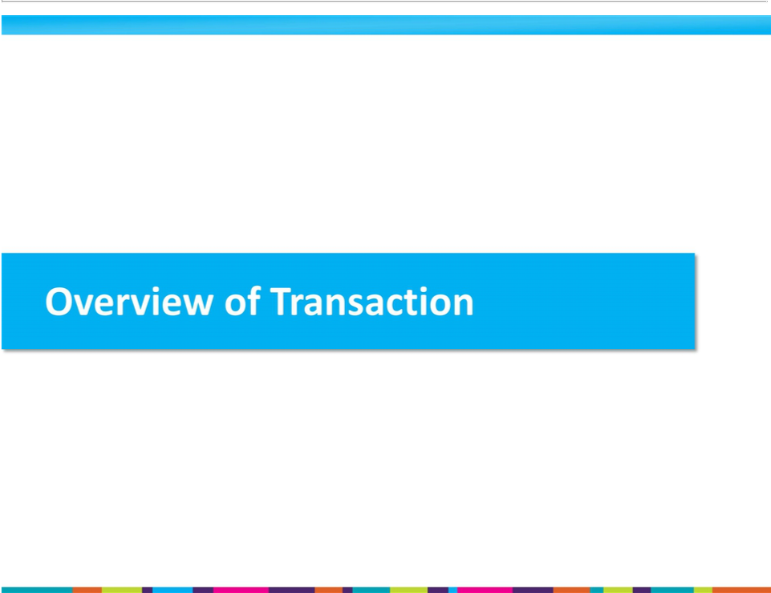

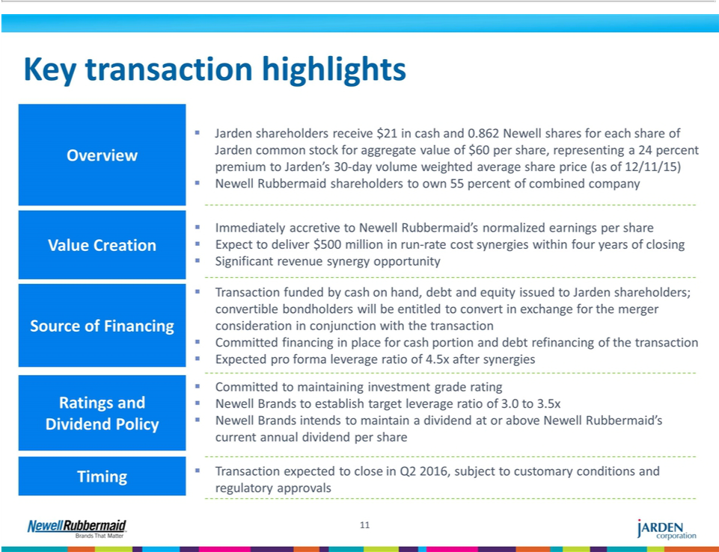

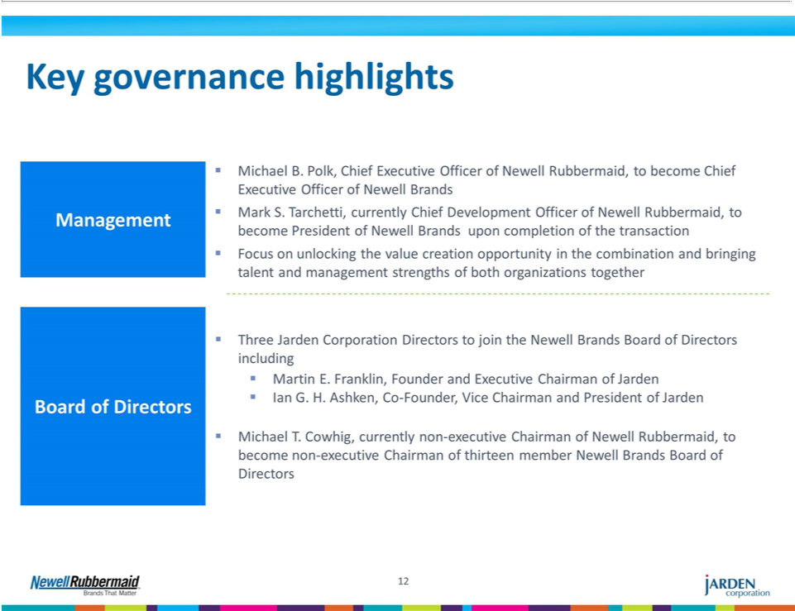

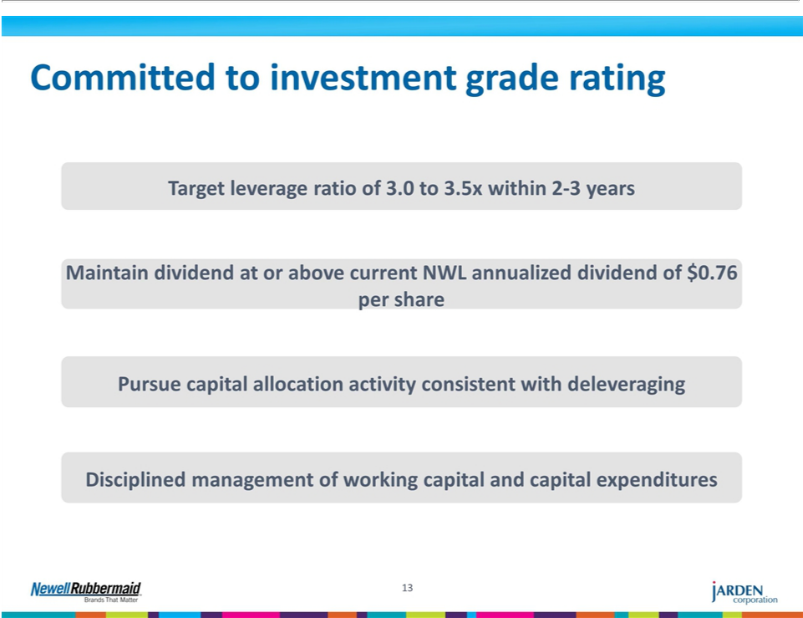

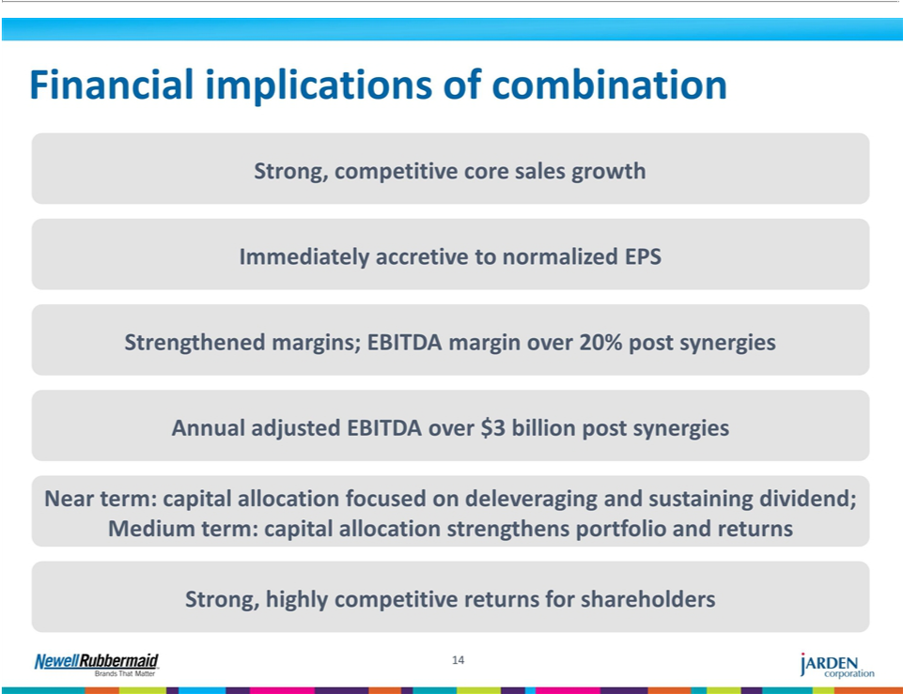

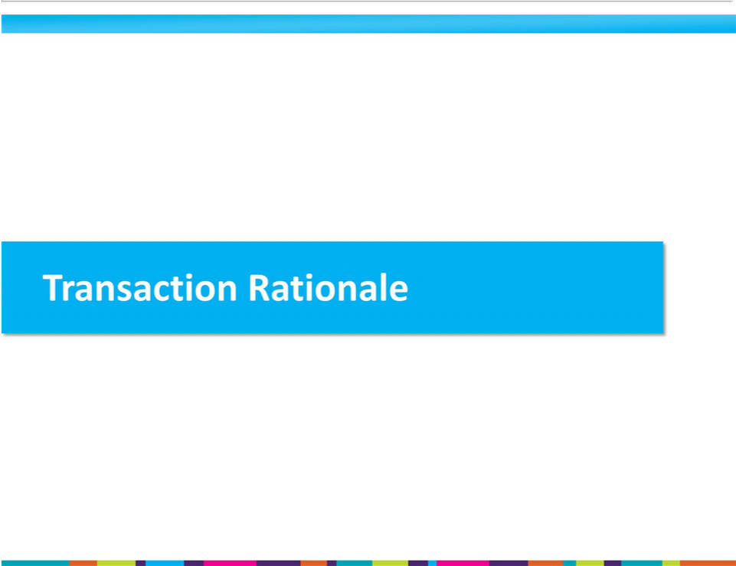

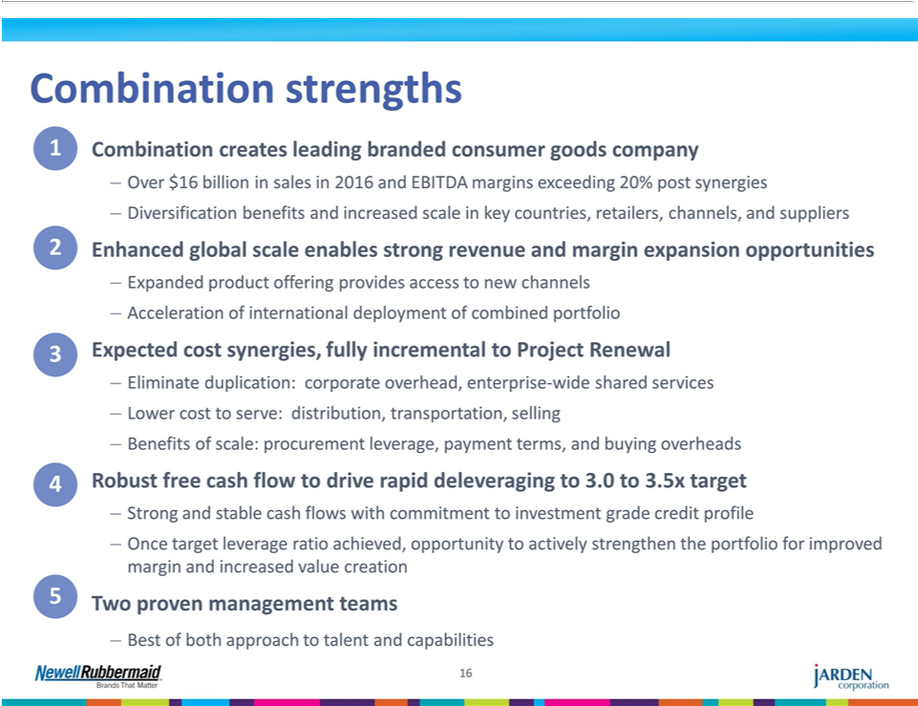

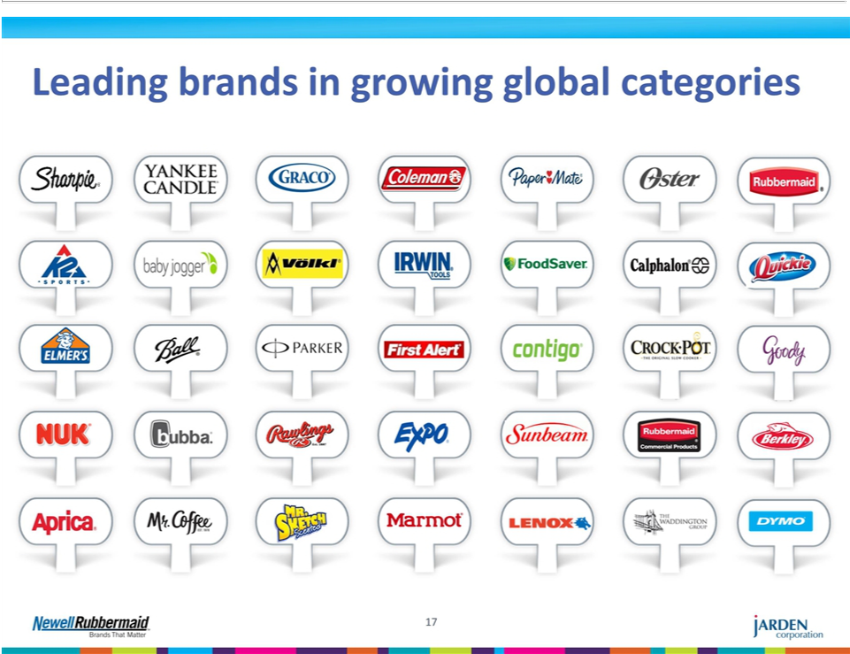

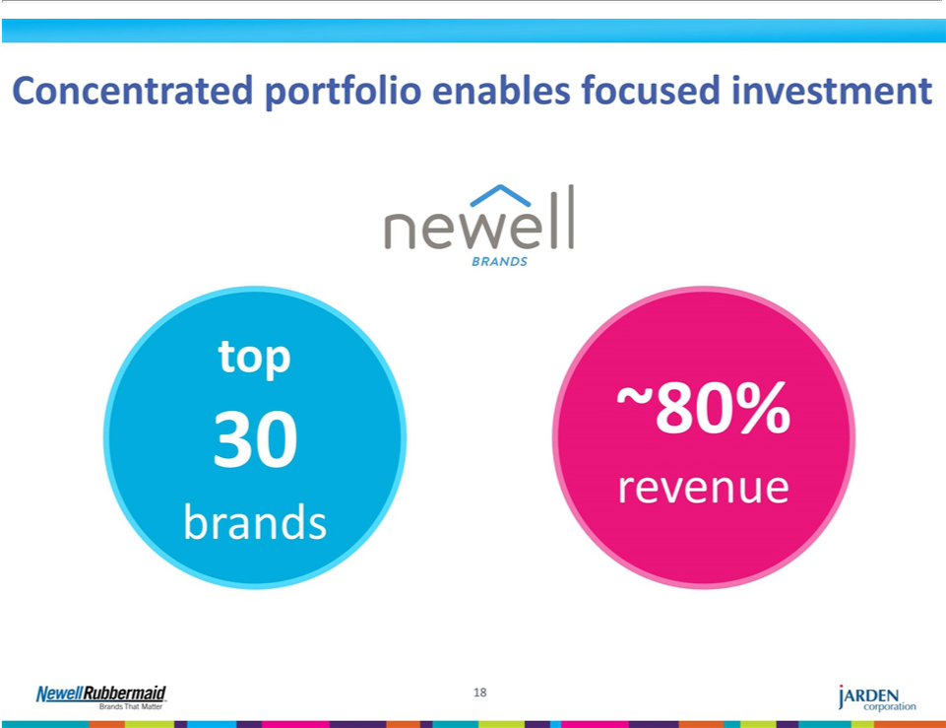

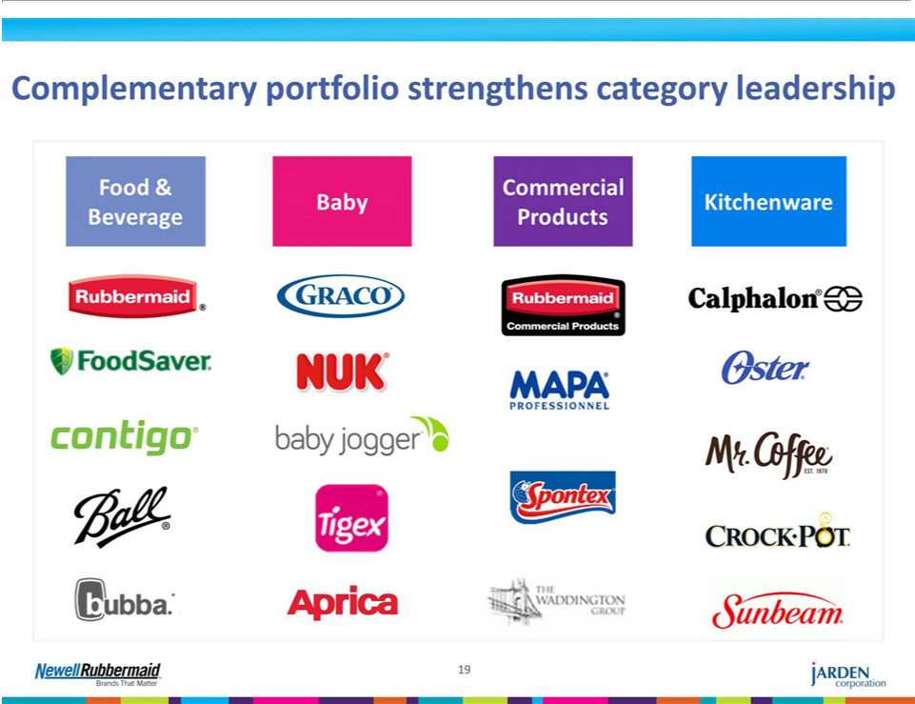

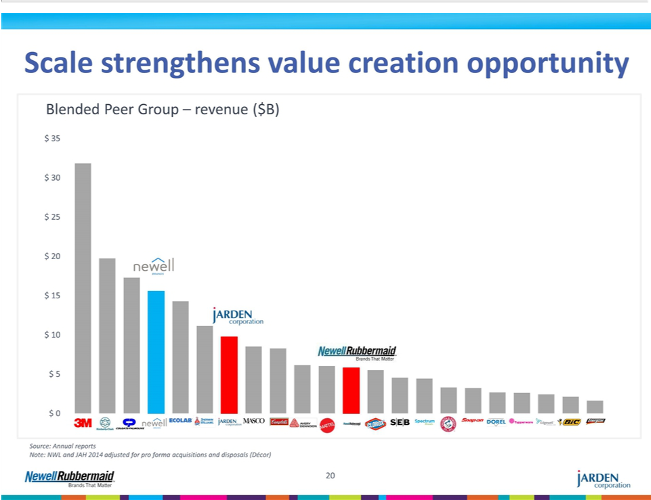

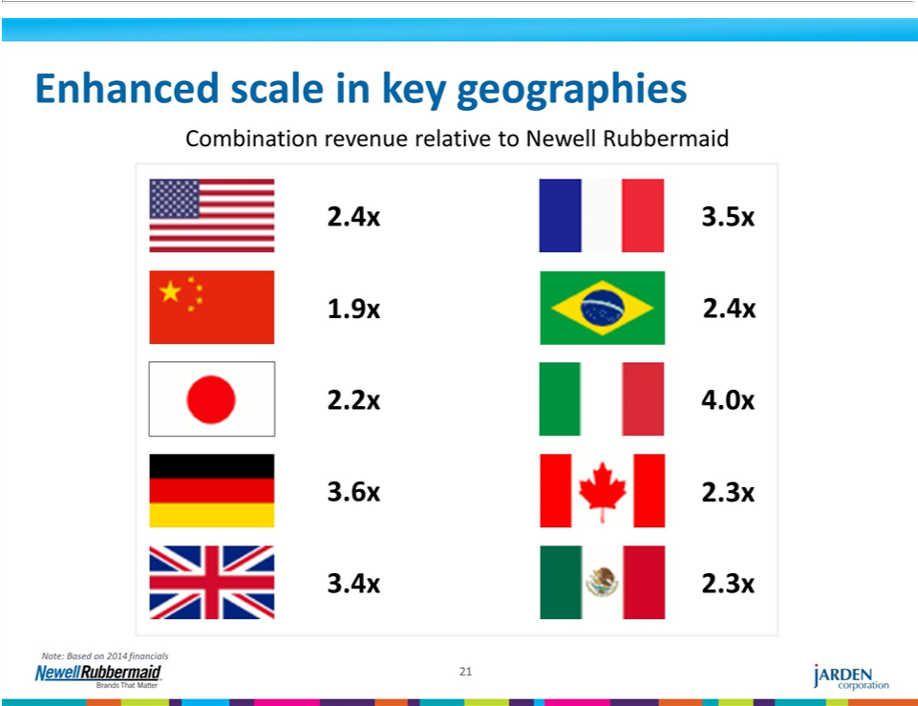

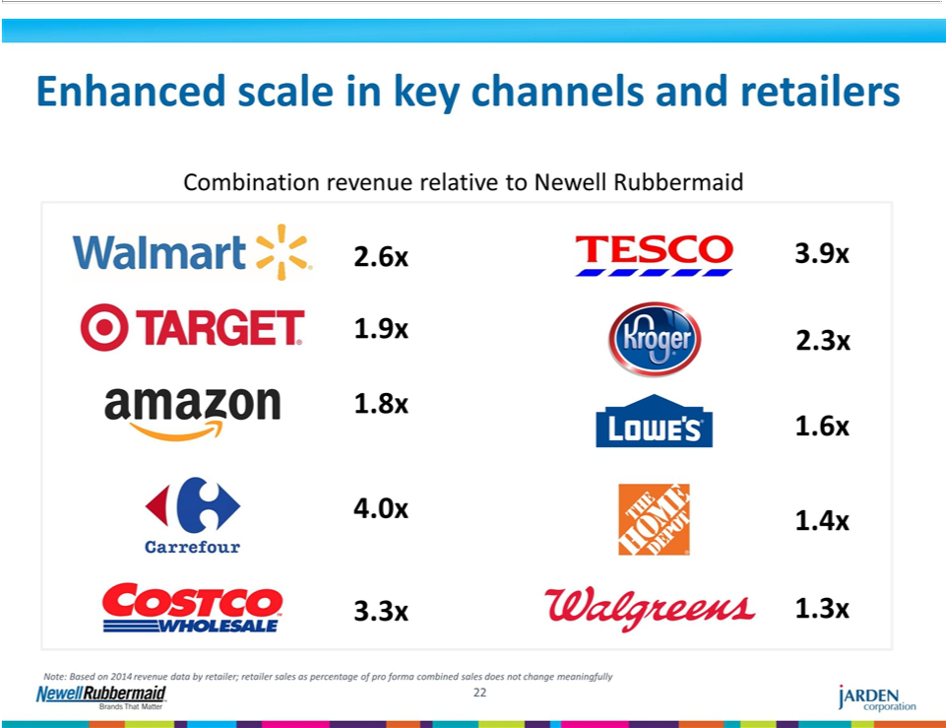

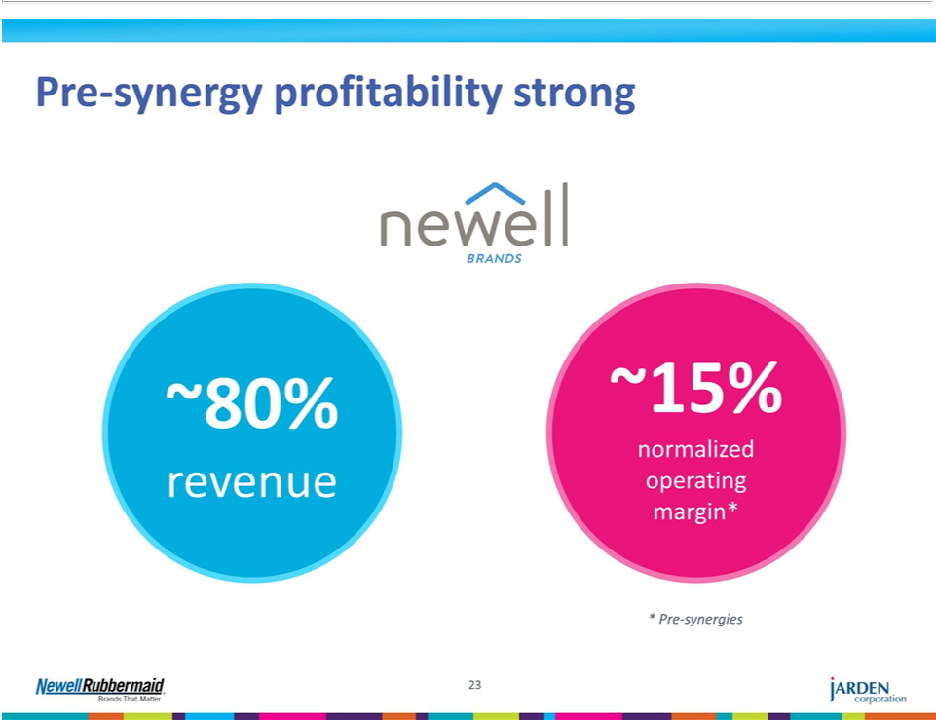



Exhibit 99.3

The following communication was first sent to Newell Rubbermaid employees beginning on December 14, 2015.

Dear Colleagues,

Today I am excited to share with you that we have entered into a definitive agreement to acquire Jarden Corporation for a consideration of cash and equity. Upon completion of the transaction, our new combined company will be a $16 billion branded goods powerhouse which will be called Newell Brands. Jarden is a leading, global consumer products company with over 120 brands, most notably Yankee Candle®, Crock-Pot®, FoodSaver®, Mr. Coffee®, Oster®, Sunbeam®, Coleman®, First Alert®, Jostens®, Nuk®, Oster®, Rawlings®, K2®, Marker®, Marmot®, Volkl®, and many others.

This combination allows both companies to achieve all the benefits of scale with an increasingly global footprint, a significant increase in the size of our business with key customers around the world and many cost efficiencies. Through the combination, we will create a new level of potential for our brands and our people, and over the long term we will look to build one of the largest, most successful branded consumer products companies in the world.

We are excited that these brands will become part of our portfolio. This intended combination continues to drive the company’s growth agenda and is another step toward Newell becoming one of the preeminent branded consumer goods companies in the world.

By bringing together Newell Rubbermaid and Jarden, we will unlock accelerated value creation for both sets of shareholders. These two companies have some of the strongest track records of shareholder return in the last 5 years. The scale of our combined businesses in key categories, channels and geographies creates a much broader canvas on which to leverage our advantaged set of brand development and commercial capabilities for accelerated growth and margin expansion.

We expect to complete the deal by the end of Q2 2016, subject to approval by shareholders of both Newell Rubbermaid and Jarden, receipt of regulatory approvals and other customary closing conditions. Upon completion of the deal, three members of the Jarden Board will join our Board of Directors and Michael Cowhig will continue as non-executive Chairman of the Newell Brands Board of Directors. I will lead Newell Brands as Chief Executive Officer. We will continue run both businesses as both do today with each focused on their respective 2016 business plans.

Mark Tarchetti, currently our Chief Development Officer, will lead the integration of our companies and will serve as President of Newell Brands upon the closing of the transaction. Mark will initially focus on bringing both companies together, delivering the synergies and developing a new combined portfolio strategy and long-term business development plans such as accelerated market deployment of the brands at home and internationally. He will also be responsible for the creation of a number of enterprise-wide capabilities, including Design, Innovation, Insights, eCommerce, and Direct-to-Consumer commerce.

Bill Burke, our Chief Operating Officer, has agreed to lead the legacy Jarden business upon the closing of the transaction, working closely with the existing Jarden leadership team to deliver their business plans and partnering with Mark on the transition of Jarden into Newell Brands. I’m delighted that Bill and Mark will continue their partnership.

As previously announced, Joe Arcuri will assume the role of Chief Commercial Officer of Newell Rubbermaid and Richard Davies will become Chief Development Officer of Newell Rubbermaid, both effective January 1, 2016. Joe and Richard will focus on delivering the existing Newell Rubbermaid business plan. Additional executive roles will be announced at the completion of the proposed transaction and in the meantime, it is business as usual for both leadership teams.

I am very excited about the potential this combination can bring to our company. This acquisition positions us for long term industry leadership and we are able to undertake this from a position of strength with very strong performance in 2015 and a powerful 2016 plan ahead of us. The combination will make us even stronger. I have long respected the value creation track record and entrepreneurial vision of Martin Franklin and Ian Ashken, the Founder and co-Founder of Jarden. They began their company from a standing start in 2001 and in only fourteen years built a business with revenue of over $10 billion with brands consumers use every day.

I am very proud of the team of people that have worked tirelessly over the last several weeks to bring this transaction to the point of announcement. I am thrilled to bring these two great companies together and look forward to realizing the full possibilities of this powerful combination. The creation of Newell Brands will accelerate our Growth Game Plan ambition of becoming one of the preeminent branded consumer goods companies in the world.

I look forward to welcoming the Jarden team to our company and realizing the full possibilities of this powerful combination. Thank you for your hard work which well positioned us for this opportunity and stay focused on delivering a strong 2015.

Caution Concerning Forward Looking Statements

Statements that are not historical in nature constitute forward-looking statements. These forward-looking statements relate to information or assumptions about the timing of completion of the proposed combination, the expected benefits of the proposed combination, management’s plans, projections and objectives for future operations, scale and performance, integration plans and expected synergies therefrom, and anticipated future financial and operating performance results, including operating margin or gross margin capital and other expenditures, cash flow, dividends, restructuring and other project costs, costs and cost savings, and debt ratings. These statements are accompanied by words such as “anticipate,” “expect,” “project,” “will,” “believe,” “estimate” and similar expressions. Such expectations are based upon certain preliminary information, internal estimates, and management assumptions, expectations, and plans, and are subject to a number of risks and uncertainties inherent in projecting future conditions, events, and results. Actual results could differ materially from those expressed or implied in the forward-looking statements if one or more of the underlying assumptions or expectations prove to be inaccurate or are unrealized. Important factors that could cause actual results to differ materially from those suggested by the forward-looking statements include, but are not limited to, the occurrence of any event, change or other circumstances that could give rise to the termination of the merger agreement; the risk that the necessary shareholder approvals may not be obtained; the risk that the necessary regulatory approvals may not be obtained or may be obtained subject to conditions that are not anticipated; the risk that the proposed combination will not be consummated in a timely manner; risks that any of the closing conditions to the proposed combination may not be satisfied or may not be satisfied in a timely manner; risks related to disruption of management time from ongoing business operations due to the proposed combination; the risk that we are unable to retain our investment grade rating; failure to realize the benefits expected from the proposed combination; failure to promptly and effectively integrate the combination; and the effect of the announcement of the proposed combination on the ability of Newell Rubbermaid to retain customers and retain and hire key personnel, maintain relationships with suppliers, on its operating results and businesses generally and those factors listed in Newell Rubbermaid’s most recently filed Quarterly Report on Form 10-Q and exhibit 99.1 thereto, in each case, filed with the Securities and Exchange Commission (“SEC”). Changes in such assumptions or factors could produce significantly different results. The information contained in this communication is as of the date indicated. Newell Rubbermaid does not assume any obligation to update any forward-looking statements contained in this communication as a result of new information or future events or developments.

Additional Information and Where to Find It

In connection with the proposed combination, Newell Rubbermaid and Jarden will file a registration statement on Form S-4 that will include the Joint Proxy Statement of Newell Rubbermaid and Jarden that also constitutes a prospectus of Newell Rubbermaid. Newell Rubbermaid and Jarden plan to mail to their respective shareholders the Joint Proxy Statement/Prospectus in connection with the combination. WE URGE INVESTORS AND SHAREHOLDERS TO READ THE JOINT PROXY STATEMENT/PROSPECTUS AND ANY OTHER RELEVANT DOCUMENTS WHEN THEY BECOME AVAILABLE, BECAUSE THEY WILL CONTAIN IMPORTANT INFORMATION ABOUT NEWELL RUBBERMAID, JARDEN, AND THE PROPOSED COMBINATION. Investors and shareholders will be able to obtain copies of the Joint Proxy Statement/Prospectus and other documents filed with the SEC by Newell Rubbermaid and Jarden free of charge at the SEC’s website, www.sec.gov. In addition, investors and shareholders will be able to obtain free copies of the Joint Proxy Statement/Prospectus and other documents filed with the SEC by Newell Rubbermaid by accessing Newell Rubbermaid’s website at www.newellrubbermaid.com by clicking on the “Investor Relations” link and then clicking on the “SEC Filings” link or by contacting Newell Rubbermaid Investor Relations at investor.relations@newellrubbermaid.com or by calling 1-800-424-1941, and will be able to obtain free copies of the Joint Proxy Statement/Prospectus and other documents filed with the SEC by Jarden by accessing Jarden’s website at www.Jarden.com by clicking on the “For Investors” link and then clicking on the “SEC Filings” link or by contacting Jarden Investor Relations at rwilson@jarden.com or by calling 203-845-5300. Shareholders may also read and copy any reports, statements and other information filed by Newell Rubbermaid or Jarden with the SEC, at the SEC public reference room at 100 F Street, N.E., Washington D.C. 20549. Please call the SEC at 1-800-SEC-0330 or visit the SEC’s website for further information on its public reference room.

Participants in the Merger Solicitation

Newell Rubbermaid, Jarden and certain of their respective directors, executive officers and other persons may be considered participants in the solicitation of proxies from the respective shareholders of Newell Rubbermaid and Jarden in respect of the proposed combination contemplated by the Joint Proxy Statement/Prospectus. Information regarding Newell Rubbermaid’s directors and executive officers is available in Newell Rubbermaid’s Form 10-K filed with the SEC on March 2, 2015, its proxy statement filed with the SEC on April 1, 2015 in connection with its 2015 annual meeting of stockholders and its Forms 8-K filed with the SEC on February 12, 2015, May 19, 2015, October 9, 2015 and November 16, 2015. Information regarding Jarden’s directors and executive officers is available in Jarden’s Form 10-K filed with the SEC on March 2, 2015, its proxy statement filed with the SEC on April 20, 2015 in connection with its 2015 annual meeting of stockholders and its Forms 8-K filed with the SEC on January 5, 2015 and June 9, 2015. Other information regarding persons who may be considered participants in the proxy solicitation and a description of their direct and indirect interests, by security holdings or otherwise, will be contained in the Joint Proxy Statement/Prospectus and other relevant materials to be filed with the SEC when they become available.

Non-Solicitation

This communication is not intended to and does not constitute an offer to sell or the solicitation of an offer to subscribe for or buy or an invitation to purchase or subscribe for any securities or the solicitation of any vote or approval in any jurisdiction pursuant to the combination or otherwise, nor shall there be any sale, issuance or transfer of securities in any jurisdiction in contravention of applicable law. No offer of securities shall be made except by means of a prospectus meeting the requirements of Section 10 of the Securities Act of 1933, as amended.

Exhibit 99.4

The following communication was first posted on December 14, 2015.

Connect Article

We Made a Deal

Newell Rubbermaid and Jarden Corporation announce plans to become Newell Brands

Global Communications

Today marks an important moment for Newell Rubbermaid as we announced this morning our agreement to combine with Jarden Corporation, a leading global consumer products company with over 120 brands, most notably Yankee Candle®, Rawlings®, Crock-Pot®, FoodSaver®, Mr. Coffee®, Oster®, Sunbeam®, Coleman®, First Alert®, Jostens®, Nuk®, Oster®, and many others. The potential of this combination is exciting for many reasons – it positions us for long-term industry leadership and enables us to accelerate the ideas and execution of our Growth Game Plan as we seek to become a larger, faster growing, more global and more profitable company.

Our executive leadership team, led by our President and CEO, Michael Polk, has been clear about our aspiration to become one of the world’s preeminent consumer goods companies. Our agreement to combine with Jarden Corporation is another step toward realizing this ambition. Our new combined company, which will be called Newell Brands, will create a $16 billion branded consumer goods powerhouse. Through the combination, we will create a new level of potential for our brands and our people.

We have been bold and strategic about plans to acquire leading brands and obtain greater market share in the future. Just two months ago, we welcomed Elmer’s Products, Inc.

and the iconic Elmer’s®, Krazy Glue®, and X-Acto® brands to our portfolio. We look forward to welcoming the Jarden team to our company in Q2 2016.

“The combination of these two great companies creates a $16 billion powerhouse in the branded goods landscape with incredible potential to grow and create value,” said Polk in a news release out this morning. He went on to add that, “the scale of our combined businesses in key categories, channels and geographies creates a much broader canvas on which to leverage our advantaged set of brand development and commercial capabilities for accelerated growth and margin expansion.”

With this latest deal, our sights continue to be set on growth and expansion. As The Newell Way states, “we are here to make Newell a leader in our industry,” and we are well on our way.

1

Leading our path forward will be our current CEO, Michael Polk, who will become CEO of Newell Brands. Martin E. Franklin, Executive Chairman and Founder of Jarden, and Jarden co-founder Ian Ashken, will transition to new roles on Newell Brands’ Board of Directors.

Mark Tarchetti, Chief Development Officer of Newell Rubbermaid, will work to integrate the two companies as the President of Newell Brands upon the closing of the transaction.

As President, Tarchetti will leverage the synergy of both companies in delivery, portfolio strategy and long-term business development plans such as accelerated market deployment of the brands at home and internationally. He will also be responsible for the creation of a number of enterprise-wide capabilities, including Design, Innovation, Insights, eCommerce, and Direct-to-Consumer commerce.

“I am thrilled to have the opportunity to be part of the Newell Brands journey,” said Tarchetti. “Our Growth Game Plan has always been about unlocking our full potential and this transformative combination is a giant step forward on delivering on those ambitions. Having spent a lot of time in recent weeks looking at all the opportunities we can imagine with the Jarden business, I am proud we got this deal over the line and can’t wait to get started on the opportunity. Two of the highest-performing companies in our industry coming together can create transformative new value creation.”

Bill Burke, currently Chief Operating Officer of Newell Rubbermaid, has agreed to lead the Jarden business upon the closing of the transaction working closely with the existing Jarden team to develop and deliver the business plans while working with Tarchetti to ensure the seamless transition of Jarden into Newell Brands.

“I’ve been looking for the next big opportunity, and as it turns out, I didn’t need to look far,” was Burke’s comment. “Leading the Jarden side of Newell Brands with over 120 brands, more than 35,000 employees, and revenue spanning to more than 125 countries, was an attractive opportunity for me, and I look forward to continuing to lead as we start this next chapter.”

Our CEO is also pleased with these appointments, expressing “given the magnitude of the transition ahead, I’m delighted that Bill and Mark will continue their partnership,” said Polk.

As previously announced, Joe Arcuri will assume the role of Chief Commercial Officer of Newell Rubbermaid and Richard Davies will become Chief Development Officer of Newell Rubbermaid, both effective January 1, 2016. These leaders will ensure the development and full delivery of the existing Newell Rubbermaid business plan.

While we’ve made some decisions about the leadership, it is still early in the coming together of these two companies. The deal isn’t expected to close until Q2 2016. So for the time being, it’s business as usual.

2

Share your excitement about this latest acquisition in the comment box below.

Caution Concerning Forward Looking Statements

Statements that are not historical in nature constitute forward-looking statements. These forward-looking statements relate to information or assumptions about the timing of completion of the proposed combination, the expected benefits of the proposed combination, management’s plans, projections and objectives for future operations, scale and performance, integration plans and expected synergies therefrom, and anticipated future financial and operating performance results, including operating margin or gross margin capital and other expenditures, cash flow, dividends, restructuring and other project costs, costs and cost savings, and debt ratings. These statements are accompanied by words such as “anticipate,” “expect,” “project,” “will,” “believe,” “estimate” and similar expressions. Such expectations are based upon certain preliminary information, internal estimates, and management assumptions, expectations, and plans, and are subject to a number of risks and uncertainties inherent in projecting future conditions, events, and results. Actual results could differ materially from those expressed or implied in the forward-looking statements if one or more of the underlying assumptions or expectations prove to be inaccurate or are unrealized. Important factors that could cause actual results to differ materially from those suggested by the forward-looking statements include, but are not limited to, the occurrence of any event, change or other circumstances that could give rise to the termination of the merger agreement; the risk that the necessary shareholder approvals may not be obtained; the risk that the necessary regulatory approvals may not be obtained or may be obtained subject to conditions that are not anticipated; the risk that the proposed combination will not be consummated in a timely manner; risks that any of the closing conditions to the proposed combination may not be satisfied or may not be satisfied in a timely manner; risks related to disruption of management time from ongoing business operations due to the proposed combination; the risk that we are unable to retain our investment grade rating; failure to realize the benefits expected from the proposed combination; failure to promptly and effectively integrate the combination; and the effect of the announcement of the proposed combination on the ability of Newell Rubbermaid to retain customers and retain and hire key personnel, maintain relationships with suppliers, on its operating results and businesses generally and those factors listed in Newell Rubbermaid’s most recently filed Quarterly Report on Form 10-Q and exhibit 99.1 thereto, in each case, filed with the Securities and Exchange Commission (“SEC”). Changes in such assumptions or factors could produce significantly different results. The information contained in this communication is as of the date indicated. Newell Rubbermaid does not assume any obligation to update any forward-looking statements contained in this communication as a result of new information or future events or developments.

Additional Information and Where to Find It

In connection with the proposed combination, Newell Rubbermaid and Jarden will file a registration statement on Form S-4 that will include the Joint Proxy Statement of Newell Rubbermaid and Jarden that also constitutes a prospectus of Newell Rubbermaid. Newell Rubbermaid and Jarden plan to mail to their respective shareholders the Joint Proxy Statement/Prospectus in connection with the combination. WE URGE INVESTORS AND SHAREHOLDERS TO READ THE JOINT PROXY STATEMENT/PROSPECTUS AND ANY OTHER RELEVANT DOCUMENTS WHEN THEY BECOME AVAILABLE, BECAUSE THEY WILL CONTAIN IMPORTANT INFORMATION ABOUT NEWELL RUBBERMAID, JARDEN, AND THE PROPOSED COMBINATION. Investors and shareholders will be able to obtain copies of the Joint Proxy Statement/Prospectus and other documents filed with the SEC by Newell Rubbermaid and Jarden free of charge at the SEC’s website, www.sec.gov. In addition, investors and shareholders will be able to obtain free copies of the Joint Proxy Statement/Prospectus and other documents filed with the SEC by Newell Rubbermaid by accessing Newell Rubbermaid’s website at www.newellrubbermaid.com by clicking on the “Investor Relations” link and then clicking on the “SEC Filings” link or by contacting Newell Rubbermaid Investor Relations at investor.relations@newellrubbermaid.com or by calling 1-800-424-1941, and will be able to obtain free copies of the Joint Proxy Statement/Prospectus and other documents filed with the SEC by Jarden by accessing Jarden’s website at www.Jarden.com by clicking on the “For Investors” link and then clicking on the “SEC Filings” link or by contacting Jarden Investor Relations at

3

rwilson@jarden.com or by calling 203-845-5300. Shareholders may also read and copy any reports, statements and other information filed by Newell Rubbermaid or Jarden with the SEC, at the SEC public reference room at 100 F Street, N.E., Washington D.C. 20549. Please call the SEC at 1-800-SEC-0330 or visit the SEC’s website for further information on its public reference room.

Participants in the Merger Solicitation

Newell Rubbermaid, Jarden and certain of their respective directors, executive officers and other persons may be considered participants in the solicitation of proxies from the respective shareholders of Newell Rubbermaid and Jarden in respect of the proposed combination contemplated by the Joint Proxy Statement/Prospectus. Information regarding Newell Rubbermaid’s directors and executive officers is available in Newell Rubbermaid’s Form 10-K filed with the SEC on March 2, 2015, its proxy statement filed with the SEC on April 1, 2015 in connection with its 2015 annual meeting of stockholders and its Forms 8-K filed with the SEC on February 12, 2015, May 19, 2015, October 9, 2015 and November 16, 2015. Information regarding Jarden’s directors and executive officers is available in Jarden’s Form 10-K filed with the SEC on March 2, 2015, its proxy statement filed with the SEC on April 20, 2015 in connection with its 2015 annual meeting of stockholders and its Forms 8-K filed with the SEC on January 5, 2015 and June 9, 2015. Other information regarding persons who may be considered participants in the proxy solicitation and a description of their direct and indirect interests, by security holdings or otherwise, will be contained in the Joint Proxy Statement/Prospectus and other relevant materials to be filed with the SEC when they become available.

Non-Solicitation

This communication is not intended to and does not constitute an offer to sell or the solicitation of an offer to subscribe for or buy or an invitation to purchase or subscribe for any securities or the solicitation of any vote or approval in any jurisdiction pursuant to the combination or otherwise, nor shall there be any sale, issuance or transfer of securities in any jurisdiction in contravention of applicable law. No offer of securities shall be made except by means of a prospectus meeting the requirements of Section 10 of the Securities Act of 1933, as amended.

4

Exhibit 99.5

The following communication was first sent to Newell Rubbermaid customers beginning on December 14, 2015.

Email to Newell Rubbermaid Customers

[DATE]

Dear [CUSTOMER NAME]:

Today I am excited to share with you that Newell Rubbermaid has entered into a definitive agreement to acquire Jarden Corporation, creating a $16 billion consumer branded goods powerhouse to be called Newell Brands.

With over 120 leading brands, Jarden is a great match for us as they share our commitment to building a brand-led company. This acquisition allows both of us to be a stronger partner with you — as we will now have the resources to invest in our business so we can add more value to you, our customers, along with a great portfolio of leading brands and the combined strengths and resources of two leading companies.

Newell Brands will be able to use its increased scale and combined product portfolio to further brand development and commercial capabilities, while unlocking efficiencies in procurement, infrastructure and cost to create new opportunities in the global marketplace.

For now, it’s business as usual for us, and you will continue to be called on and served as you are today. We anticipate the transaction will close in Q2 2016 and are committed to keeping you fully informed of our business plans.

We look forward to continuing to strengthen our relationship with you and encourage you to contact

if you have any questions.

Sincerely,

Joe Cavaliere

Newell Rubbermaid Customer Contact

Caution Concerning Forward Looking Statements

Statements that are not historical in nature constitute forward-looking statements. These forward-looking statements relate to information or assumptions about the timing of completion of the proposed combination, the expected benefits of the proposed combination, management’s plans, projections and objectives for future operations, scale and performance, integration plans and expected synergies therefrom, and anticipated future financial and operating performance results, including operating margin or gross margin capital and other expenditures, cash flow, dividends, restructuring and other project costs, costs and cost savings, and debt ratings. These statements are accompanied by words such as “anticipate,” “expect,” “project,” “will,” “believe,” “estimate” and similar expressions. Such expectations are based upon certain preliminary information, internal estimates, and management assumptions, expectations, and plans, and are subject to a number of risks and uncertainties inherent in projecting future conditions, events, and results. Actual results could differ materially from those expressed or implied in the forward-looking statements if one or more of the underlying assumptions or expectations prove to be inaccurate or are unrealized. Important factors that could cause actual results to differ materially from those suggested by the forward-looking statements include, but are not limited to, the occurrence of any event, change or other circumstances that could give rise to the termination of the merger agreement; the risk that the necessary shareholder approvals may not be obtained; the risk that the necessary regulatory approvals may not be obtained or may be obtained subject to conditions that are not anticipated; the risk that the proposed combination will not be consummated in a timely manner; risks that any of the closing conditions to the proposed combination may not be satisfied or may not be satisfied in a timely manner; risks related to disruption of management time from ongoing business operations due to the proposed combination; the risk that we are unable to retain our investment grade rating; failure to realize the benefits expected from the proposed combination; failure to promptly and effectively integrate the combination; and the effect of the announcement of the proposed combination on the ability of Newell Rubbermaid to retain customers and retain and hire key personnel, maintain relationships with suppliers, on its operating results and businesses generally and those factors listed in Newell Rubbermaid’s most recently filed Quarterly Report on Form 10-Q and exhibit 99.1 thereto, in each case, filed with the Securities and Exchange Commission (“SEC”). Changes in such assumptions or factors could produce significantly different results. The information contained in this communication is as of the date indicated. Newell Rubbermaid does not assume any obligation to update any forward-looking statements contained in this communication as a result of new information or future events or developments.

Additional Information and Where to Find It

In connection with the proposed combination, Newell Rubbermaid and Jarden will file a registration statement on Form S-4 that will include the Joint Proxy Statement of Newell Rubbermaid and Jarden that also constitutes a prospectus of Newell Rubbermaid. Newell Rubbermaid and Jarden plan to mail to their respective shareholders the Joint Proxy Statement/Prospectus in connection with the combination. WE URGE INVESTORS AND SHAREHOLDERS TO READ THE JOINT PROXY STATEMENT/PROSPECTUS AND ANY OTHER RELEVANT DOCUMENTS WHEN THEY BECOME AVAILABLE, BECAUSE THEY WILL CONTAIN IMPORTANT INFORMATION ABOUT NEWELL RUBBERMAID, JARDEN, AND THE PROPOSED COMBINATION. Investors and shareholders will be able to obtain copies of the Joint Proxy Statement/Prospectus and other documents filed with the SEC by Newell Rubbermaid and Jarden free of charge at the SEC’s website, www.sec.gov. In addition, investors and shareholders will be able to obtain free copies of the Joint Proxy Statement/Prospectus and other documents filed with the SEC by Newell Rubbermaid by accessing Newell Rubbermaid’s website at www.newellrubbermaid.com by clicking on the “Investor Relations” link and then clicking on the “SEC Filings” link or by contacting Newell Rubbermaid Investor Relations at investor.relations@newellrubbermaid.com or by calling 1-800-424-1941, and will be able to obtain free copies of the Joint Proxy Statement/Prospectus and other documents filed with the SEC by Jarden by accessing Jarden’s website at www.Jarden.com by clicking on the “For Investors” link and then clicking on the “SEC Filings” link or by contacting Jarden Investor Relations at rwilson@jarden.com or by calling 203-845-5300. Shareholders may also read and copy any reports, statements and other information filed by Newell Rubbermaid or Jarden with the SEC, at the SEC public reference room at 100 F Street, N.E., Washington D.C. 20549. Please call the SEC at 1-800-SEC-0330 or visit the SEC’s website for further information on its public reference room.

Participants in the Merger Solicitation

Newell Rubbermaid, Jarden and certain of their respective directors, executive officers and other persons may be considered participants in the solicitation of proxies from the respective shareholders of Newell Rubbermaid and Jarden in respect of the proposed combination contemplated by the Joint Proxy Statement/Prospectus. Information regarding Newell Rubbermaid’s directors and executive officers is available in Newell Rubbermaid’s Form 10-K filed with the SEC on March 2, 2015, its proxy statement filed with the SEC on April 1, 2015 in connection with its 2015 annual meeting of stockholders and its Forms 8-K filed with the SEC on February 12, 2015, May 19, 2015, October 9, 2015 and November 16, 2015. Information regarding Jarden’s directors and executive officers is available in Jarden’s Form 10-K filed with the SEC on March 2, 2015, its proxy statement filed with the SEC on April 20, 2015 in connection with its 2015 annual meeting of stockholders and its Forms 8-K filed with the SEC on January 5, 2015 and June 9, 2015. Other information regarding persons who may be considered participants in the proxy solicitation and a description of their direct and indirect interests, by security holdings or otherwise, will be contained in the Joint Proxy Statement/Prospectus and other relevant materials to be filed with the SEC when they become available.

Non-Solicitation

This communication is not intended to and does not constitute an offer to sell or the solicitation of an offer to subscribe for or buy or an invitation to purchase or subscribe for any securities or the solicitation of any vote or approval in any jurisdiction pursuant to the combination or otherwise, nor shall there be any sale, issuance or transfer of securities in any jurisdiction in contravention of applicable law. No offer of securities shall be made except by means of a prospectus meeting the requirements of Section 10 of the Securities Act of 1933, as amended.

